Self Maintenance AM/PM 20 Minutes

JIN SHIN JYUTSU®
"The Artless Art of Getting to Know (Help) Myself"
The Main Central Vertical Flow is the source of our life energy. This pathway runs down the center of the front of the body and back up the spine. Here is a Jin Shin Jyutsu® self-help process to harmonize this pathway.
Harmonizing the Main Central regularly helps you feel centered and ensures that you will have plenty of energy. Some people find it calming and use it to fall asleep, while others like to use it to clear away the cobwebs upon awakening. For optimum results, do this daily.
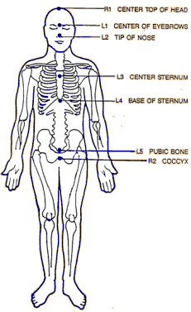
MAIN CENTRAL VERTICAL FLOW
Step 1: Place the fingers of the right hand on the top of the head (where they will remain until step 6). Place the fingers of the left hand o your forehead between your eyebrows. Hold for 2 to 5 minutes or until the pulses you feel at your fingertips synchronize with each other.
Step 2: Now move the left fingertips to the tip of the nose. Hold them there for 2 to 5 minutes, or until the pulses synchronize.
Step 3: Move the left fingertips to your sternum (center of your chest between your breasts). Stay there for 2 to 5 minutes, or until the pulses synchronize.
Step 4: Move your fingers to the base of your sternum (center of where your ribs start, above the stomach). Hold them there for 2 to 5 minutes, or until the pulses synchronize.
Step 5: Move your fingers to the top of your pubic bone (above the genitals, center). Stay there for 2 to 5 minutes, or until the pulses synchronize.
Step 6: Keep your left fingertips in place and move your right fingertips to cover your coccyx (tailbone). Hold for 2 to 5 minutes or until the pulses you feel at your fingertips synchronize with each other.
Note: The right hand remains on the top of the head while the left hand moves down the body until the final step.

